Smart Waste Management System

Phase 1
100 Points
System Requirements Specification

# | Name | ID | Group
1 | Mena Mohamed Sultan | 20245068 | 3
2 | Gehan Mohamed Selim | 20245016 | 3
3 | Sophia Muhammad Raafat | 20247002 | 3
4 | Youssef Mahmoud elSawy | 20246137 | 3

Project Team leader email: sofia_badr@icloud.com

Project Team leader mobile:
01555155134

TA. <Nada <3>

Project phase1 SRS should include:
- Purpose (5 points)
- Scope (5 points)
- Stakeholders (5 points)
- Abbreviation & Glossary (5 points)
- Assumptions and/or constraints (10 points)
- User requirements (15 points)
- System Requirements
  - Functional Requirements (15 points)
<at least 6 requirements>
  - Non-Functional Requirements. (10 points)
<at least 4 requirements>
- Use case Diagram (15 points)
- Use case Tables (15 points)
<at least 6 tables>
- Acceptance Tests Plan (15 points)
At least one acceptance test per functional requirement
- Each test should include:
  - Test ID
  - Description
  - Inputs / Preconditions
  - Expected Output / Acceptance Criteria

- Purpose:
The Smart Waste Management System aims to preserve city cleanliness and improve operational efficiency in waste collection. It ensures timely collection through automated bin notifications, reduces the occurrence of overflowing bins, optimizes drivers’ routes for better resource utilization, and provides citizens with a cleaner and healthier urban environment.
- Scope:
The Smart Waste Management System is designed to improve the efficiency and organization of municipal waste collection through the use of smart bins equipped with fill-level sensors. The system automatically monitors the status of bins, sends notifications when they reach capacity, and assists in planning optimized collection routes. It provides a centralized platform for administrators to track bin conditions and for drivers to receive updated collection tasks. The system focuses on automation, timely waste collection, and cleaner urban environments.
-Included: Smart bin monitoring, automated notifications, route optimization, and administrative dashboards.
-Excluded: Manual waste collection operations, physical sensor design, and vehicle maintenance management.

- Stakeholders:
- Citizens:
Citizens use the system to report issues such as broken, full, or unclean bins. They contribute indirectly by disposing of waste in smart bins equipped with sensors that detect fill levels.
- Drivers:
Drivers receive their daily collection schedules and optimized routes from the central system. They log in to the system to view assigned bins, empty them, and confirm completion. The system automatically verifies bin status through the sensors.
- Supervisors:
Supervisors monitor all complaints (pending, resolved, or rejected) submitted by citizens or generated by the system. They are responsible for assigning unresolved complaints to technicians and overseeing their progress.
- Technicians:
Technicians access the system to view complaints assigned by supervisors. They inspect bins or sensors to identify and fix issues, resolve faults, and submit resolution reports to confirm completion.
- Administrators:
Administrators manage system users, roles, and permissions. They oversee overall system operations, ensure data consistency, and maintain the performance of the central platform. They may also generate reports and monitor system analytics to support decision-making.

- Abbreviations and Glossary:

Term / Abbreviation | Definition
Administrator (Admin) | A user with system-level access to manage accounts, monitor performance, and maintain the platform.
Central System / Server | The backend system that collects data from bins, generates optimal routes, and manages users and complaints.
Complaint | A report submitted by citizens or generated automatically by the system when an issue with a bin is detected.
Complaint Status | The stage of a complaint within the system: Pending, Resolved, or Rejected.
Driver | A system user who empties assigned bins according to the optimized routes and confirms task completion.
GUI (Graphical User Interface) | The visual part of the application that allows users to interact with the system.
IoT (Internet of Things) | The network of physical objects (such as smart bins) embedded with sensors that exchange data over the Internet.
Notification | A system alert sent automatically when a bin reaches its threshold or when an issue is detected.
Penalty | A record applied to a driver when a bin remains full after being marked as emptied and no sensor fault is detected.
Route Optimization | The process of generating the most efficient collection paths for drivers, minimizing time and distance.
Sensor | A hardware component placed in each bin to detect and measure its fill level.
Smart Bin | A waste container equipped with sensors and connectivity for monitoring fill status and reporting data to the central system.
SOLID Principles | A set of five object-oriented design principles that improve code structure and maintainability.
SRS (Software Requirements Specification) | The formal document that defines the system’s requirements.
Supervisor | A system user responsible for managing complaints and assigning tasks to technicians.
SWMS (Smart Waste Management System) | The name of the software system being developed.
Technician | A system user who handles and resolves issues reported in the system, such as sensor malfunctions or bin repairs.
Three-Tier Architecture | A software design pattern dividing the system into Presentation, Logic, and Data tiers for modularity and scalability.
Threshold Level | The predefined fill percentage at which the bin sends a notification to the system (e.g., 80% full).
V-Model | A software development model emphasizing validation and verification at each stage of development.

- Assumptions and Constraints:
- Assumptions:
- All smart bins are equipped with functioning sensors capable of measuring fill levels accurately.
- The system has stable Internet connectivity between smart bins, drivers’ devices, and the central server.
- Drivers and technicians have mobile devices capable of running the system’s application.
- Each user has valid login credentials and Internet access.
- The municipality provides regular maintenance for bins and sensors.
- The central system has sufficient storage and processing capacity for all data collected from bins.
- Notifications from sensors are sent in real-time or with minimal delay.

- Constraints:
- The system must be developed using Java or C++, as specified in the technical requirements.
- The software must follow a three-tier architecture (presentation, logic, and data layers).
- The design must comply with SOLID principles for maintainability and scalability.
- The development process must follow the V-Model, integrating testing at each phase.
- The system must handle errors gracefully with clear, user-friendly messages.
- Hardware limitations: bin sensors have limited battery life and data transmission range.
- The system must comply with municipality data privacy and security regulations.
- The system’s functionality depends on reliable GPS and network services for route optimization.
- User Requirements:
- Citizens:
- UR1: The citizen shall be able to submit a complaint if a bin is full, broken, or has a cleanliness issue.
- UR2: The citizen shall be able to view the status of their complaints (Pending, Resolved, or Rejected).
- UR3: The citizen shall be able to receive notifications when their complaint is assigned or resolved.
- Drivers:
- UR4: The driver shall be able to log in to the system.
- UR5: The driver shall be able to view their daily assigned bins for collection.
- UR6: The driver shall be able to view the optimized route for their assigned bins.
- UR7: The driver shall be able to confirm when a bin has been emptied.
- UR8: The driver shall be able to receive notifications if a bin cannot be emptied or is flagged for technician inspection.
- Supervisors:
- UR9: The supervisor shall be able to view all complaints, including pending, resolved, or rejected.
- UR10: The supervisor shall be able to assign complaints to technicians.
- UR11: The supervisor shall be able to monitor drivers’ task completion and performance.
- Technicians:
- UR12: The technician shall be able to view complaints assigned to them by supervisors.
- UR13: The technician shall be able to inspect bins or sensors and resolve problems.
- UR14: The technician shall be able to submit resolution reports for completed tasks.
- Administrators:
- UR15: The administrator shall be able to manage system users and assign roles (Driver, Supervisor, Technician).
- UR16: The administrator shall be able to monitor system performance, including bin status, notifications, and task completion.
- UR17: The administrator shall be able to generate reports on complaints, routes, and system usage.

- System Requirements:
  - Functional Requirements:
- FR1 – Bin Monitoring
The system shall receive fill-level data from all smart bins and update the central system in real-time.
- FR2 – Notifications for Full Bins
The system shall automatically notify drivers and administrators when a bin reaches the predefined threshold.
- FR3 – Driver Task Management
Drivers shall be able to log in, view their daily assigned bins, follow the optimized route, and confirm bin emptying.
- FR4 – Verification & Penalty Handling
The system shall verify that a bin marked as emptied is actually empty; if not, it shall generate a complaint and record penalties if appropriate.
- FR5 – Citizen Complaint Submission
Citizens shall be able to submit complaints about full, broken, or unclean bins.
- FR6 – Supervisor Complaint Management
Supervisors shall be able to view all complaints (pending, resolved, rejected) and assign pending complaints to technicians.
- FR7 – Technician Task Management
Technicians shall be able to view assigned complaints, resolve problems, and submit resolution reports.
- FR8 – Administrative Management
Administrators shall be able to manage users, roles, permissions, and monitor system performance, including bin statuses and task completion.
  - Non-Functional Requirements:
- NFR1 – Performance
System shall process bin notifications and update dashboards within 5 seconds.
- NFR2 – Reliability
System shall maintain 99% uptime during operational hours and ensure data integrity even if a sensor or network fails.
- NFR3 – Usability
System shall provide an intuitive GUI for all users with minimal training required.
- NFR4 – Security
System shall enforce secure login, role-based access control, and encrypt sensitive data during transmission.
- NFR5 – Maintainability
System shall follow SOLID design principles and modular architecture to allow easy updates and maintenance.
- NFR6 – Scalability
System shall support the addition of new bins, users, and drivers without major redesign.

- Use case Diagram
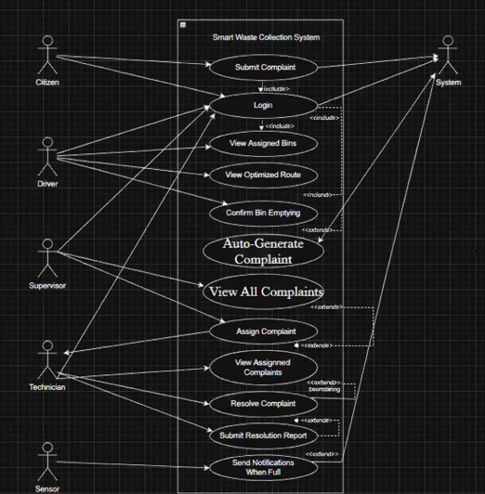
- Use Case Tables:

Field | Details
Use Case ID | UC-01
Use Case Name | Login
Actor | Any User (Driver, Citizen, Supervisor, Technician, Admin)
Description | User enters credentials to access the system.
Preconditions | User must be registered.
Postconditions | User gains access to their dashboard.
Main Flow | 1. User opens login page.  2. User enters credentials.  3. User submits form.  4. System validates credentials.  5. System grants access.
Alternative Flow | A1 – Invalid Credentials1. System rejects login.2. Error message displayed.3. User retries.

Field | Details
Use Case ID | UC-02
Use Case Name | Submit Complaint
Actor | Citizen
Description | Citizen submits a complaint (full bin, broken bin, cleanliness).
Preconditions | Citizen logged in.
Postconditions | Complaint stored as “New”.
Main Flow | 1. Citizen opens complaint form.  2. Enters bin ID and issue.  3. Submits form.  4. System saves complaint.
Alternative Flow | None.

Field | Details
Use Case ID | UC-04
Use Case Name | View Assigned Bins
Actor | Driver
Description | Driver views bins assigned for today.
Preconditions | Driver logged in; routes generated.
Postconditions | List of bins displayed.
Main Flow | 1. Driver opens dashboard.  2. Selects “Assigned Bins”.  3. System fetches assigned bins.4. Displays list.
Alternative Flow | A1 – No Bins AssignedSystem displays message.

Field | Details
Use Case ID | UC-05
Use Case Name | View Optimized Route
Actor | Driver
Description | Driver views route generated by system.
Preconditions | Driver logged in; routes exist.
Postconditions | Route displayed.
Main Flow | 1. Driver selects “Daily Route”.  2. System retrieves route.  3. System displays map/order.
Alternative Flow | None.

Field | Details
Use Case ID | UC-06
Use Case Name | Confirm Bin Emptying
Actor | Driver
Description | Driver confirms that they emptied a bin.
Preconditions | Driver logged in; bin assigned.
Postconditions | System verifies bin via sensor.
Main Flow | 1. Driver selects bin.  2. Clicks “Confirm Empty”.  3. System checks sensor reading.  4. If empty → mark completed.
Alternative Flow | A1 – Bin Not EmptySystem auto-generates complaint.

Field | Details
Use Case ID | UC-07
Use Case Name | Auto-Generate Complaint
Actor | System
Description | System creates complaint if bin still full after driver confirmation.
Preconditions | Driver submitted confirmation.
Postconditions | Complaint stored as Pending.
Main Flow | 1. System reads sensor.  2. Detects bin still full.  3. System creates complaint.  4. Marks as “Pending”.
Alternative Flow | None.

Field | Details
Use Case ID | UC-08
Use Case Name | View All Complaints
Actor | Supervisor
Description | Supervisor views list of complaints.
Preconditions | Supervisor logged in.
Postconditions | Complaints displayed.
Main Flow | 1. Supervisor selects “All Complaints”.  2. System fetches list.  3. Displays statuses.
Alternative Flow | None.

Field | Details
Use Case ID | UC-09
Use Case Name | Assign Complaint
Actor | Supervisor
Description | Assigns complaint to available technician.
Preconditions | Complaint exists; supervisor logged in.
Postconditions | Complaint assigned.
Main Flow | 1. Supervisor selects complaint.  2. Chooses technician.  3. System assigns complaint.  4. Technician notified.
Alternative Flow | A1 – No Technicians AvailableSystem displays message.

Field | Details
Use Case ID | UC-10
Use Case Name | View Assigned Complaints
Actor | Technician
Description | Technician reviews complaints assigned to them.
Preconditions | Technician logged in; complaints assigned.
Postconditions | List displayed.
Main Flow | 1. Technician selects “Assigned Complaints”.  2. System retrieves list.  3. Displays complaints.
Alternative Flow | None.

Field | Details
Use Case ID | UC-11
Use Case Name | Resolve Complaint
Actor | Technician
Description | Technician fixes issue (broken bin, sensor, or blockage).
Preconditions | Complaint assigned to technician.
Postconditions | Complaint marked as resolved.
Main Flow | 1. Technician visits bin.  2. Diagnoses issue.  3. Fixes problem.  4. Marks complaint as resolved.
Alternative Flow | A1 – Issue Cannot Be FixedTechnician flags complaint as “Unresolved”.

Field | Details
Use Case ID | UC-12
Use Case Name | Submit Resolution Report
Actor | Technician
Description | Technician submits notes describing how the issue was resolved.
Preconditions | Complaint worked on.
Postconditions | Report saved and visible to supervisor.
Main Flow | 1. Technician opens complaint.  2. Enters resolution details.  3. Submits report.  4. System stores report.
Alternative Flow | None.

Field | Details
Use Case ID | UC-14
Use Case Name | Send Notification When Full
Actor | Sensor
Description | Sensor detects bin is full and notifies system.
Preconditions | Bin exists; sensor active.
Postconditions | System marks bin as “Full”.
Main Flow | 1. Sensor measures fill level.  2. Detects threshold reached.  3. Sends notification to system.  4. System updates bin status.
Alternative Flow | None.

10. Acceptance Tests Plan

Functional Requirement ID | Functional Requirement | Test ID | Description | Inputs | Expected Output | Passed / Failed
FR1 | Citizen can log in and submit a complaint | AT1 | Verify that a citizen can log in and submit a complaint for a full, broken, or unclean bin | Valid citizen credentials, complaint details | Complaint is recorded successfully and confirmation message is displayed | Passed
FR2 | Citizen can view complaint status | AT2 | Verify that a citizen can view the status of previously submitted complaints | Citizen login, existing complaints | System displays correct status (Pending, Resolved, Rejected) | Untested
FR3 | Citizen receives complaint notifications | AT3 | Verify that the citizen receives notifications when complaint is assigned or resolved | Complaint assignment or resolution event | Notification appears in account or via email/app | Untested
FR4 | Driver can log in | AT4 | Verify that a driver can log in using valid credentials | Valid driver credentials | Driver dashboard loads successfully | Untested
FR5 | Driver can view assigned bins | AT5 | Verify that the driver can view the list of bins assigned for daily collection | Driver login | Assigned bins with correct locations are displayed | Untested
FR6 | Driver can view optimized route | AT6 | Verify that the driver can view an optimized route covering all assigned bins | Assigned bin locations | Optimized route is displayed correctly | Untested
FR7 | Driver can mark bin as emptied | AT7 | Verify that the driver can mark a bin as emptied after collection | Bin selection, completion action | Bin status updates to “Empty” with timestamp | Untested
FR8 | Driver receives bin issue notifications | AT8 | Verify that the driver receives notifications when a bin cannot be emptied | Bin issue reported | Real-time notification is sent to driver | Untested
FR9 | Supervisor can view all complaints | AT9 | Verify that the supervisor can view all citizen and system-generated complaints | Supervisor login | Complete complaint list with correct statuses | Untested
FR10 | Supervisor can assign complaints | AT10 | Verify that the supervisor can assign complaints to technicians | Complaint selection, technician assignment | Complaint is assigned and visible to technician | Untested
FR11 | Supervisor can monitor drivers | AT11 | Verify that supervisor can monitor driver task completion and performance | Driver activity data | Dashboard shows updated driver performance metrics | Untested
FR12 | Technician can view assigned complaints | AT12 | Verify that the technician can view complaints assigned by supervisors | Technician login | Assigned complaints displayed with details | Untested
FR13 | Technician can resolve complaints | AT13 | Verify that technician can inspect bins/sensors and resolve issues | Inspection and resolution action | Complaint status updates to “Resolved” | Untested
FR14 | Technician can submit resolution report | AT14 | Verify that technician can submit a resolution report | Resolution report data | Report is saved and linked to complaint | Untested
FR15 | Administrator can manage users | AT15 | Verify that administrator can create, update, and remove users and assign roles | User details, role data | Users are managed successfully with correct roles | Untested
FR16 | Administrator can monitor system | AT16 | Verify that administrator can monitor system performance and bin status | System metrics data | Accurate performance metrics and bin statuses displayed | Untested
FR17 | Administrator can generate reports | AT17 | Verify that administrator can generate system reports | Report type selection | Reports generated and downloadable (PDF, CSV) | Untested

Smart Waste Management System

Phase 2
100 Points
System Requirements Specification

# | Name | ID | Group
1 | Mena Mohamed Sultan | 20245068 | 3
2 | Gehan Mohamed Selim | 20245016 | 3
3 | Sophia Muhammad Raafat | 20247002 | 3
4 | Youssef Mahmoud elSawy | 20246137 | 3

Project Team leader email: sofia_badr@icloud.com

Project Team leader mobile:
01555155134

TA. <Nada>

Project phase2 should include:

1. Class Diagram (20 points)
Using UML, draw the class diagram expressing the system classes with different
attributes and operations

- At least provide 1 Generalization relationship
- At least 8 classes
- Do not leave any class without associating it to at least 1 other class.
- Use ArgoUML or visual-paradigm to Draw the class diagram

2. Sequence Diagram (25 points)
Provide sequence diagrams based on number of use cases at most 10 and at least
6 [Focusing on main features]
Use ArgoUML or visual-paradigm to Draw the sequence diagram

3. Activity Diagram (25 points)
Provide activity diagrams based on number of use cases at most 10 and at least 6
[Focusing on main features]
Use ArgoUML or visual-paradigm to Draw the activity diagram

4. State transition Diagram ( 20 points)
Provide State transition diagrams at most 10 and at least 6
[Focusing on main features]
Use ArgoUML or visual-paradigm to Draw the State Transition diagram

5. Validation against Acceptance Testing Plan (10 points)
Review all diagrams and models created in Phase 2, and ensure that each test from the Acceptance Tests defined in Phase 1 is correctly represented.

Class Diagram:

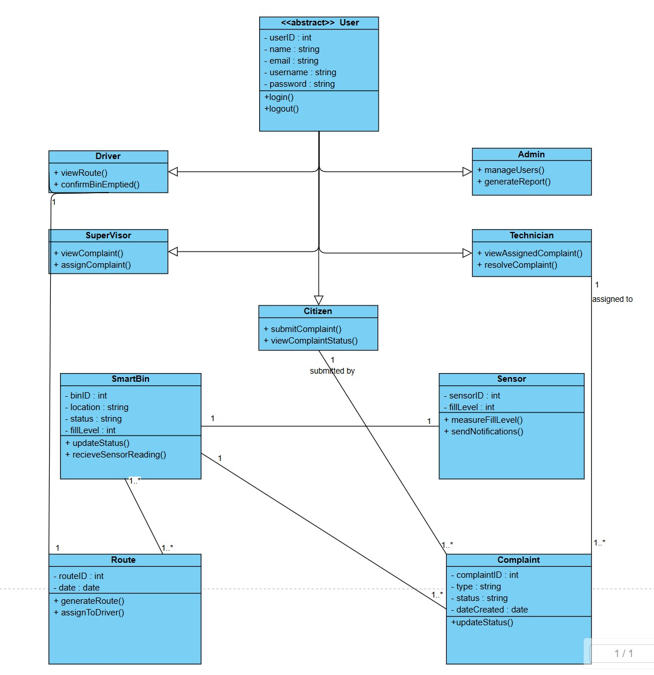

Sequence Diagram:

Report Bin Issue:

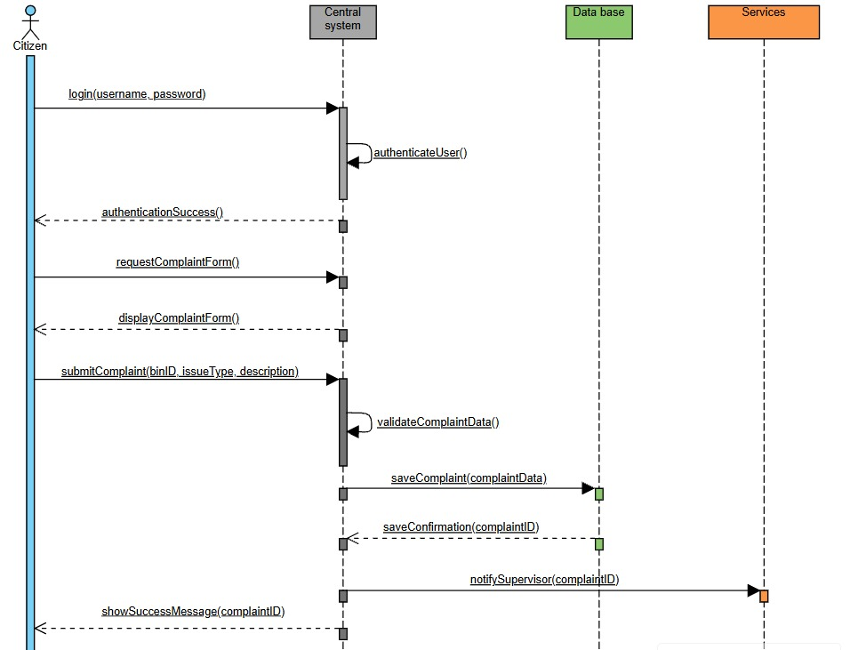

View Optimized Route (Driver):

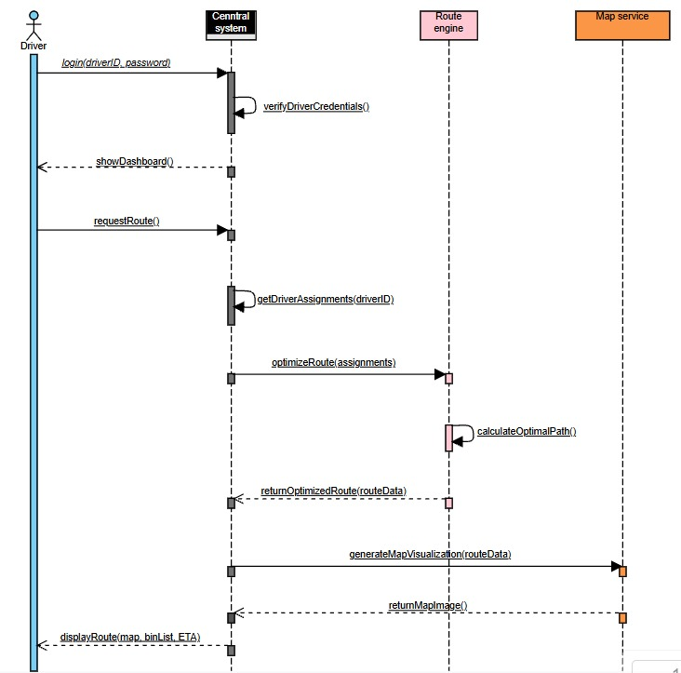

Confirm Bin Is Emptied:

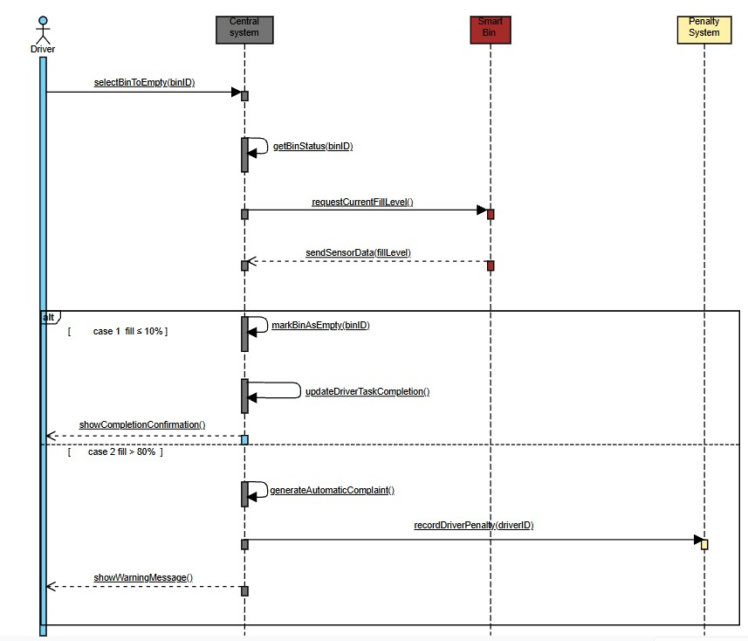

Assign Issue to Technician (Supervisor):

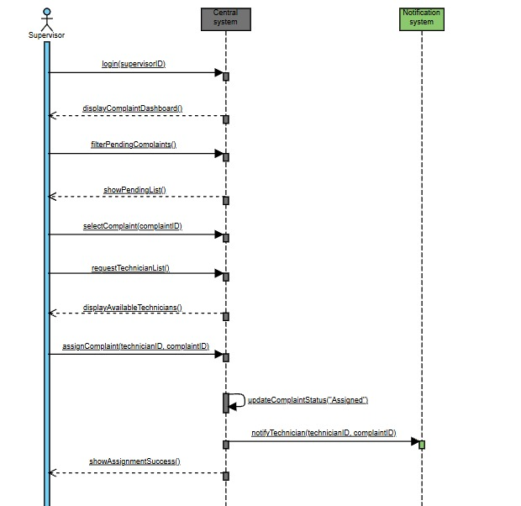

Resolve Reported Issue (Technician):

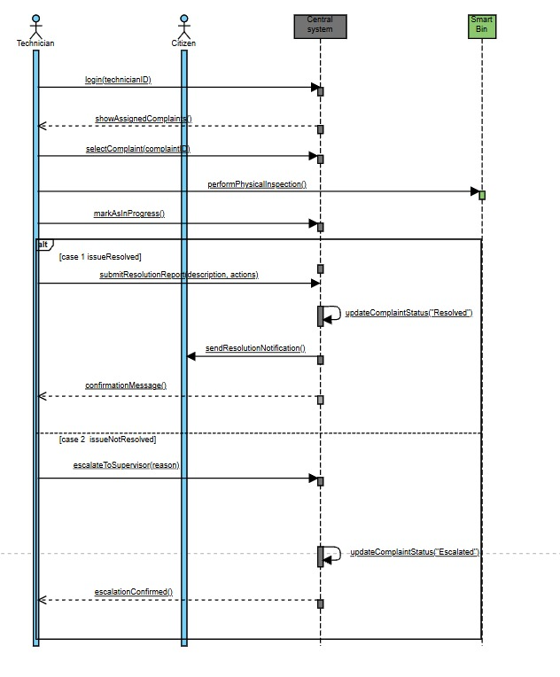

Manage Users & Roles (Admin):

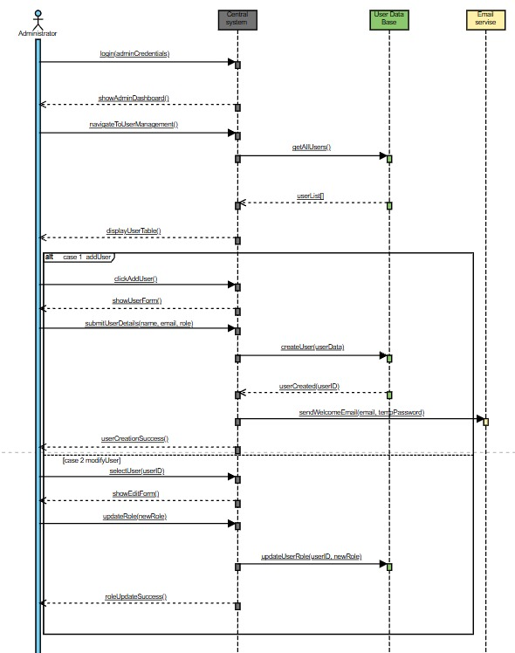

Auto-Notification (System):

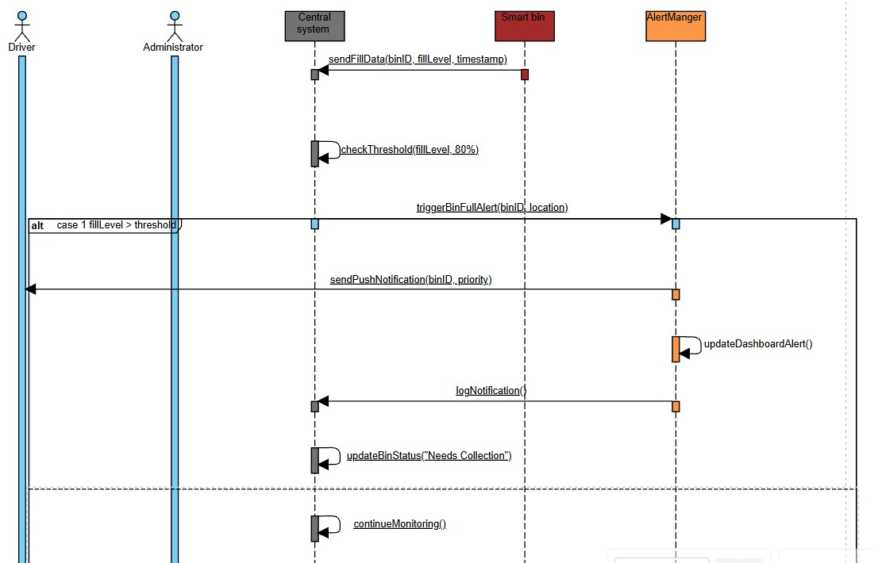

Penalty Handling Flow:

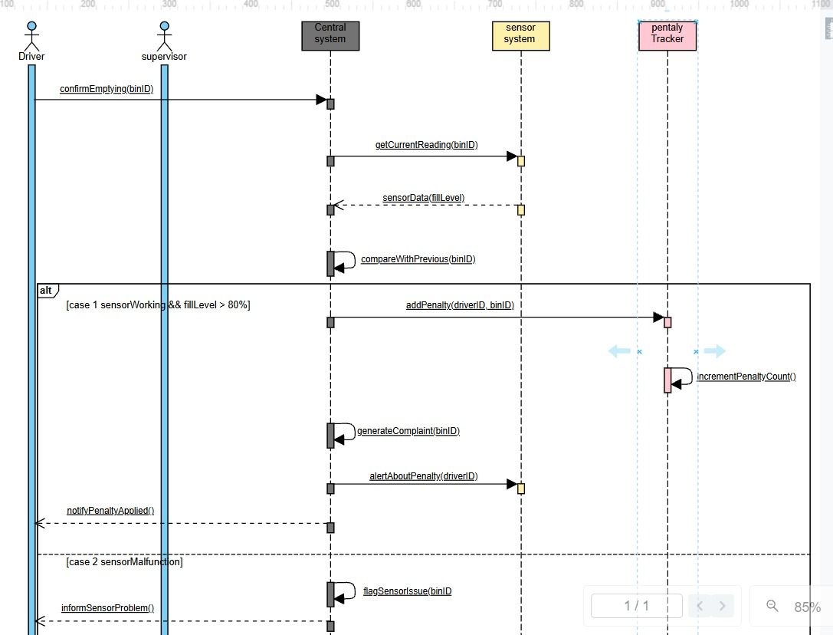

Activity Diagrams:

Login:

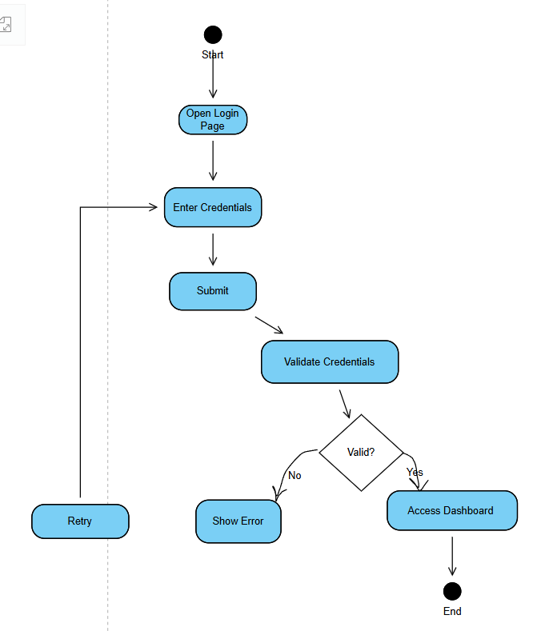

Confirm Bin Emptying:

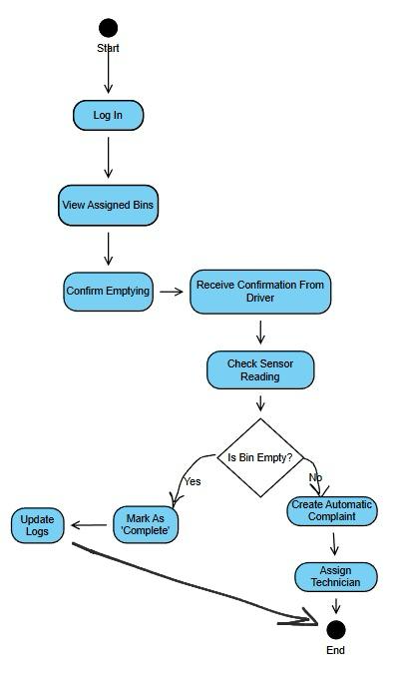

Submit Complaint:

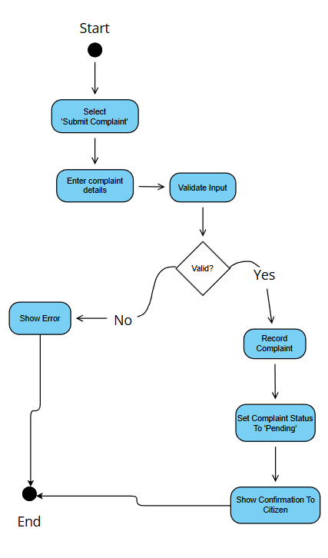

Resolve Complaint:

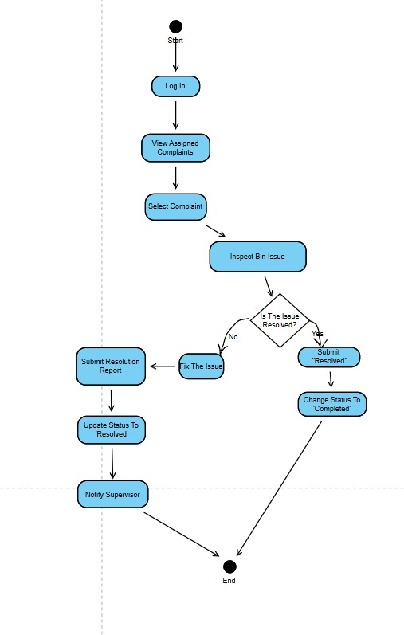

Generate Driver Route:

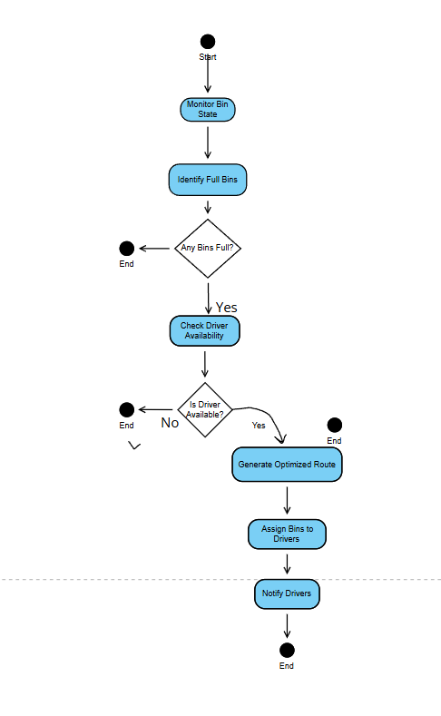

Assign Complaint:

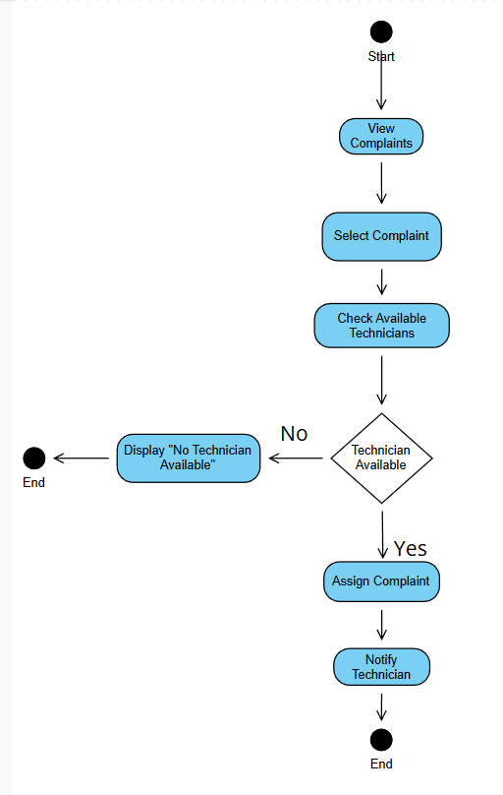

4. State transition Diagrams:

Complaint: Smart Bin:

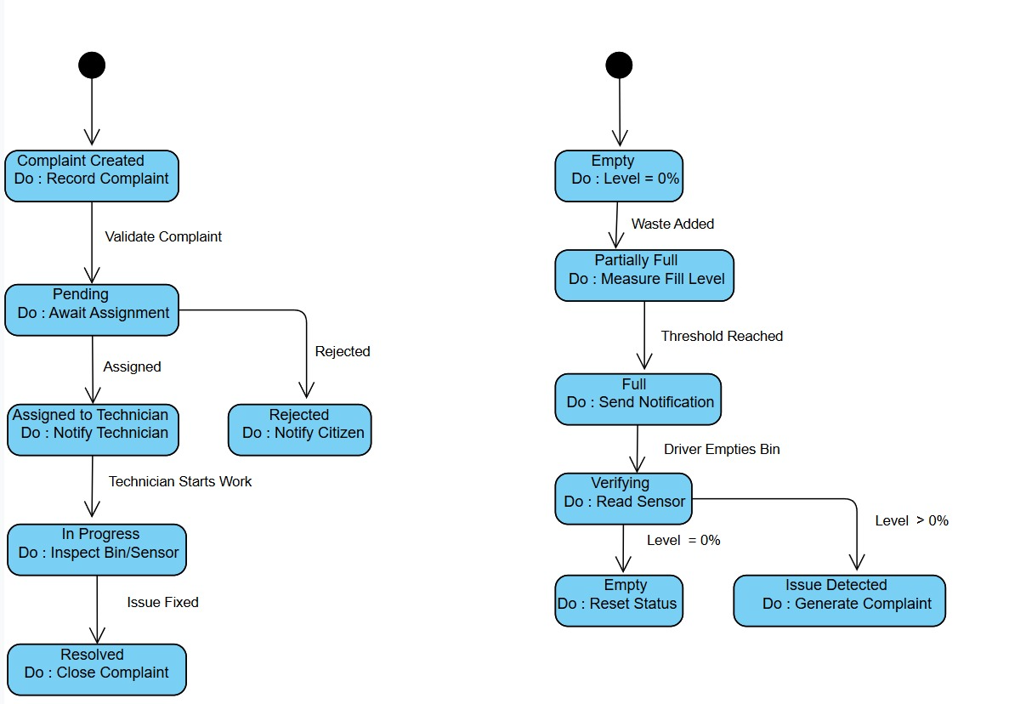

Driver Task: Sensor:

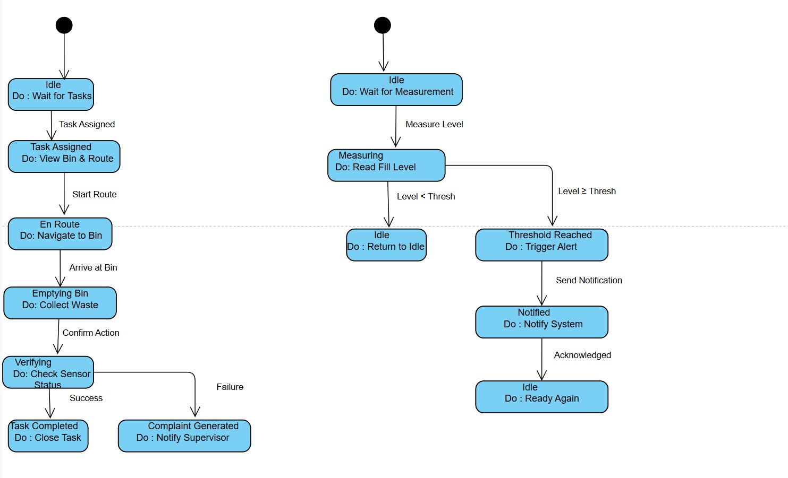

Technician: Supervisor Complaint Management:

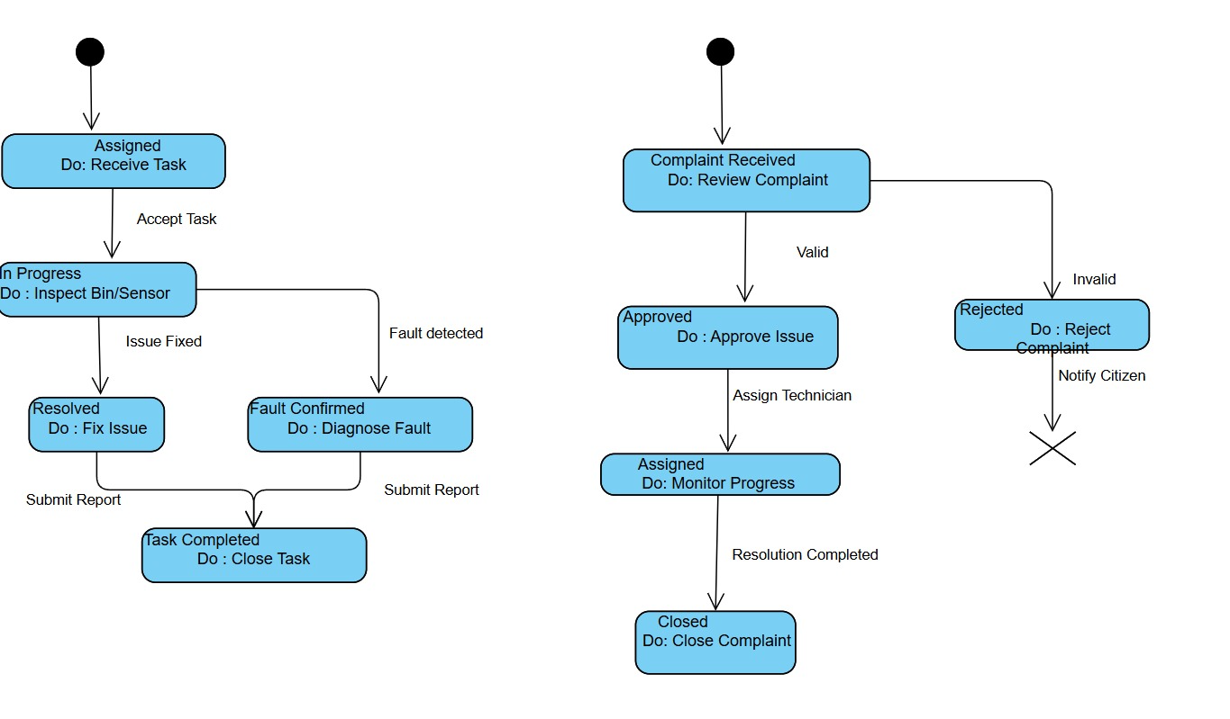

  - Validation against Acceptance Testing Plan:

Test ID | Requirement | Diagram Coverage | Status
UR1 | Citizen submits complaint | Sequence: Complaint submission; Activity: Submit Complaint; State: Complaint lifecycle | ✅ Covered
UR2 | View complaint status | Class: Complaint.status; Use Case: View Complaint; Activity: Submit Complaint | ✅ Covered
UR3 | Receive complaint notifications | Sequence: Auto-notification; State: Notification; Class: Notification | ✅ Covered
UR4 | Driver login | Sequence: Login; Activity: Login; State: Driver session | ✅ Covered
UR5 | View assigned bins | Sequence: View Assigned Bins; Activity: Confirm Bin Emptying | ✅ Covered
UR6 | View optimized route | Sequence: Route Optimization; Activity: Generate Driver Route | ✅ Covered
UR7 | Confirm bin emptied | Sequence: Bin Emptying + Sensor Verification; Activity: Confirm Bin Emptying; State: Bin status | ✅ Covered
UR8 | Receive bin issue notifications | Sequence: Auto-notification + Penalty Flow; Class: Notification | ✅ Covered
UR9 | Supervisor views complaints | Sequence: View All Complaints; Activity: Assign Complaint | ✅ Covered
UR10 | Assign complaints to technicians | Sequence: Assign Complaint; Activity: Assign Complaint | ✅ Covered
UR11 | Monitor driver performance | Sequence: Penalty Flow; Class: DriverTask, Penalty | ✅ Covered
UR12 | Technician views assigned complaints | Sequence: Resolve Complaint; Activity: Resolve Complaint | ✅ Covered
UR13 | Technician resolves issues | Sequence: Resolve Complaint; Activity: Resolve Complaint | ✅ Covered
UR14 | Submit resolution report | Sequence: Resolve Complaint; Activity: Resolve Complaint | ✅ Covered
UR15 | Admin manages users/roles | Sequence: Manage Users & Roles; Class: User generalization | ✅ Covered
UR16 | Monitor system performance | Sequence: Notification Flow; Class: SmartBin, Sensor, Route | ✅ Covered
UR17 | Generate reports | Sequence: Manage Users & Roles (report generation); Class: Report (implied) | ✅ Covered

Smart Waste Management System

Phase 3
100 Point
System Requirements Specification

# | Name | ID | Group
1 | Mena Mohamed Sultan | 20245068 | 3
2 | Gehan Mohamed Selim | 20245016 | 3
3 | Sophia Muhammad Raafat | 20247002 | 3
4 | Youssef Mahmoud elSawy | 20246137 | 3

Project Team leader email: sofia_badr@icloud.com

Project Team leader mobile:
01555155134

TA. <Nada>

Updated Class Diagram:
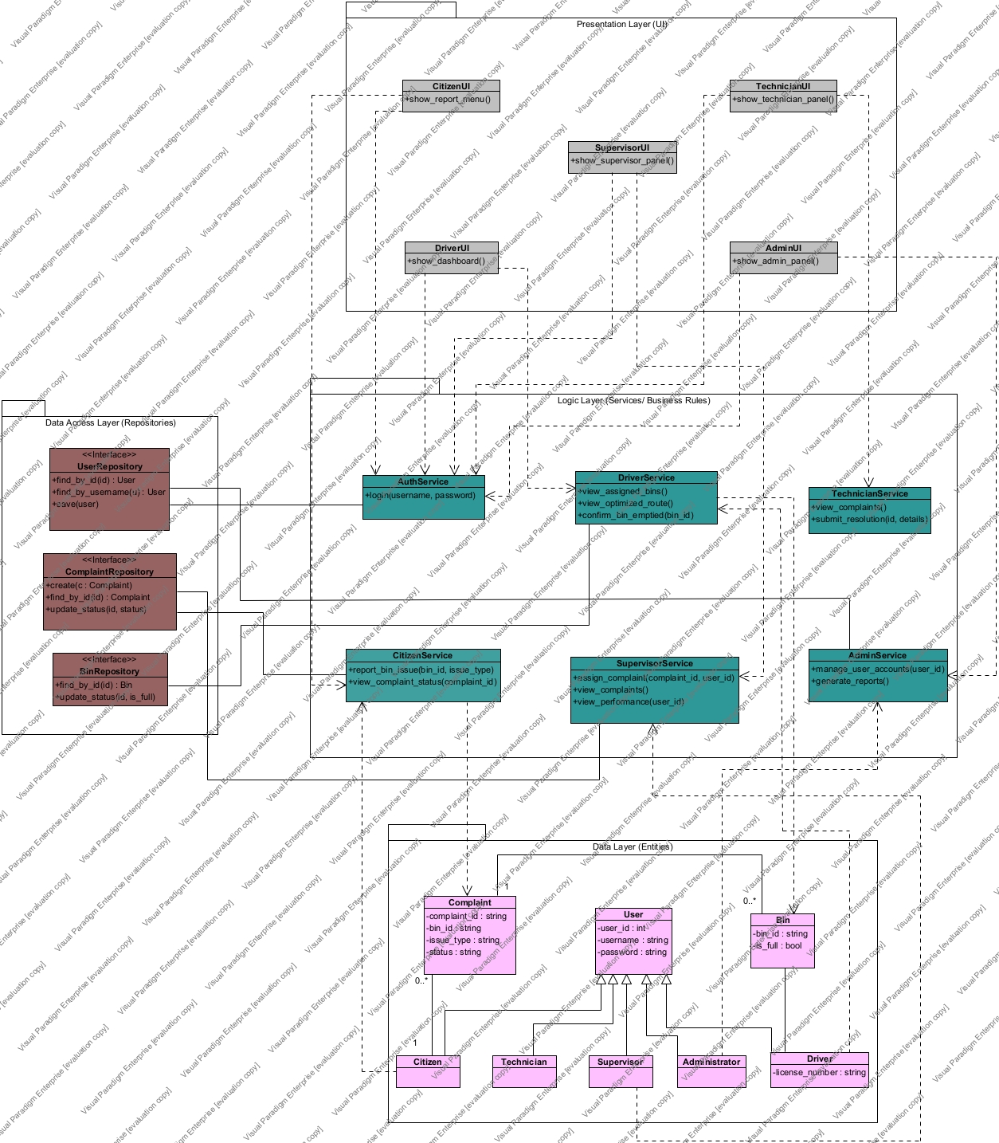

SOFTWARE DESIGN SPECIFICATION

1. PROJECT OVERVIEW

The Smart Waste Management System is designed to optimize waste collection processes through a digitized infrastructure. This document outlines the structural design and architectural patterns used to transition the system from a conceptual domain model into an implementable software solution. The design focuses on scalability, ease of maintenance, and the decoupling of system components.

2. ARCHITECTURAL DESIGN (3-TIER LAYERED PATTERN)

The system utilizes a 3-Tier Layered Architecture as described by Ian Sommerville. This pattern separates the application into three distinct layers of responsibility, ensuring that changes in one layer have minimal impact on others.

2.1 Presentation Layer (UI)

- Description: This layer manages the user interface and captures all user inputs.

- Key Classes: CitizenUI, DriverUI, TechnicianUI, SupervisorUI, and AdminUI.

- Logic: It contains no business rules or database queries; it simply delegates tasks to the Logic Layer.

2.2 Logic Layer (Services / Business Rules)

- Description: This is the "brain" of the application where business logic is executed.

- Key Classes: AuthService, CitizenService, DriverService, SupervisorService, TechnicianService, and AdminService.

- Responsibility: It processes data, validates user roles, and handles workflows like "Route Optimization" or "Complaint Assignment."

2.3 Data Access Layer (Repositories)

- Description: This layer manages all communication with the data storage system.

- Key Components: IUserRepository, IComplaintRepository, and IBinRepository.

- Implementation: It uses Interfaces to define data operations, allowing the underlying database (e.g., MySQL, File System) to be swapped without affecting the rest of the system.

3. COMPONENT RELATIONSHIPS

The system design establishes clear rules for how components interact:

- Vertical Dependencies: Layers only communicate downward. The Presentation Layer depends on the Logic Layer, which in turn depends on the Data Access Layer.

- Dependency Inversion: Services do not depend on concrete database classes; they depend on the Repository Interfaces (the Burgundy boxes in the diagram).

- Inheritance Hierarchy: All specialized users (Driver, Admin, etc.) inherit from the base User entity to maintain a consistent identity structure across the platform.

4. DATA ENTITIES

The system defines core objects that carry data between the layers. These include:

- User: Stores credentials and role-based information.

- SmartBin: Stores location data, fill levels, and status.

- Complaint: Stores issue details, reporter ID, and assigned technician.

5. PARTIAL IMPLEMENTATION SCOPE

For the Phase 3 deliverable, a vertical slice of the Citizen Reporting Module has been implemented. This implementation demonstrates the full flow of data:
- UI: CitizenUI receives the report.

- Service: CitizenService processes the logic and sets a "Pending" status.

- Repository: MySQLComplaintRepository simulates the physical storage of the record.

________________________________________________________________

Design Analysis and Reflection:

a) Changes Made to the Class Diagrams to Enforce SOLID Principles
During the transition from the Phase 2 Domain Model to the Phase 3 Layered Class Diagram, several key architectural changes were introduced to ensure full compliance with the SOLID principles and to improve system maintainability and scalability.

Single Responsibility Principle (SRP):
In the initial design, entity classes such as User were responsible for both data representation and application logic (e.g., authentication operations like login() and logout()). In the refined design, these responsibilities were separated:

- Authentication and workflow logic were moved to dedicated Service classes (e.g., AuthService).

- Data storage and retrieval were delegated to Repository classes.

- Entity classes were restricted to representing domain data only.

This separation ensures that each class has a single, well-defined reason to change, significantly improving readability and maintainability.
Dependency Inversion Principle (DIP):
A major structural improvement was introduced in the Logic Layer, where services no longer depend directly on concrete database implementations. Instead:

- Business logic depends on repository interfaces (e.g., IComplaintRepository).

- Concrete data access implementations depend on these interfaces, not the other way around.

This inversion of dependencies ensures that high-level policy is independent of low-level implementation details, enabling database technologies to change without impacting business logic.
Interface Segregation Principle (ISP):
To avoid oversized and tightly coupled data access components, the data layer was redesigned using multiple specialized interfaces:

- IUserRepository

- IComplaintRepository

- IBinRepository

Each service interacts only with the interface relevant to its responsibilities, preventing unnecessary dependencies and improving system modularity.
Liskov Substitution Principle (LSP):
A clear and consistent inheritance hierarchy was maintained:

- Citizen, Driver, and Admin are subclasses of the base User class.
- Any subclass instance can safely replace a User reference without altering expected system behavior.

This guarantees polymorphic substitutability, particularly during authentication and authorization processes.

b) Reducing Complexity and Maintaining Abstraction
System complexity was effectively managed by applying Sommerville’s layered architecture principles, ensuring a clear separation of concerns and strong abstraction boundaries.

Layered Decoupling:
The system was structured using a 3-Tier Architecture consisting of:

- Presentation Layer (User Interface)

- Logic Layer (Services)

- Data Access Layer (Repositories)

The Presentation Layer communicates only with the Logic Layer, never directly with the Data Access Layer. This design minimizes coupling and prevents changes in the database from propagating to the user interface.
Abstraction Through Interfaces:
Interfaces act as contracts between architectural layers:

- Service classes depend on repository interfaces rather than concrete implementations.

- The service layer defines what operations are required, while the data layer defines how those operations are executed.

This abstraction hides implementation details and allows the system to evolve without affecting higher-level components.

Encapsulation:
Entity classes enforce encapsulation by:

- Declaring attributes as private

- Exposing controlled access through public getter and setter methods

This protects internal object state and ensures that all modifications follow defined rules, reducing errors and improving reliability.

Centralized Business Rules:
All business logic is centralized within the Logic Layer (Service classes):

- Business rules are not duplicated across multiple user interface components.

- Updates to system behavior are applied in a single location.

This approach simplifies debugging, enhances consistency, and makes the system easier to maintain and extend over time.

Traceability Matrix:

Req. ID | Requirement Description | Use Case ID | Use Case Name | Design Component (Class/Service) | Test Case ID | Implementation Status
FR1 | Citizen can log in and submit a complaint | UC-01 | Submit Complaint | CitizenUI, CitizenService, IComplaintRepository, AuthService | AT1 | Implemented (Partial)
FR2 | Citizen can view complaint status | UC-02 | View Status | CitizenUI, CitizenService | AT2 | Designed
FR3 | Citizen receives complaint notifications | UC-03 | Receive Notification | CitizenService, CitizenUI | AT3 | Designed
FR4 | Driver can log in | UC-04 | Driver Login | AuthService, DriverUI | AT4 | Designed
FR5 | Driver can view assigned bins | UC-05 | View Assigned Bins | DriverUI, DriverService, IBinRepository | AT5 | Designed
FR6 | Driver can view optimized route | UC-06 | View Route | DriverUI, DriverService, IBinRepository | AT6 | Designed
FR7 | Driver can mark bin as emptied | UC-07 | Mark Bin Empty | DriverUI, DriverService, IBinRepository | AT7 | Designed
FR8 | Driver receives bin issue notifications | UC-08 | Driver Notifications | DriverService, DriverUI | AT8 | Designed
FR9 | Supervisor can view all complaints | UC-09 | View All Complaints | SupervisorUI, SupervisorService | AT9 | Designed
FR10 | Supervisor can assign complaints | UC-10 | Assign Complaint | SupervisorUI, SupervisorService, IComplaintRepository | AT10 | Designed
FR11 | Supervisor can monitor drivers | UC-11 | Monitor Drivers | SupervisorUI, SupervisorService | AT11 | Designed
FR12 | Technician can view assigned complaints | UC-12 | View Tech Complaints | TechnicianUI, TechnicianService | AT12 | Designed
FR13 | Technician can resolve complaints | UC-13 | Resolve Complaint | TechnicianUI, TechnicianService | AT13 | Designed
FR14 | Technician can submit resolution report | UC-14 | Submit Report | TechnicianUI, TechnicianService | AT14 | Designed
FR15 | Administrator can manage users | UC-15 | Manage Users | AdminUI, AdminService, IUserRepository | AT15 | Designed
FR16 | Administrator can monitor system | UC-16 | Monitor System | AdminUI, AdminService | AT16 | Designed
FR17 | Administrator can generate reports | UC-17 | Generate Reports | AdminUI, AdminService | AT17 | Designed

